View this email in your browser





hey hey heeeeey
Hi Katie!
You are hereby declared an official troublemaker of The Outdoorist Oath community!
We can’t wait to hear the stories of how y’all Oath and watch our Outdoors be transformed by our collective actions. Can we get a Woop! Woop! ???
SO! What’s Next? We knew you would ask...

FIRST: CONNECT
Join the community in our private Oath Community Hub Facebook Group, we’ll allow entry to anyone who’s taken The Oath.
If you use/connect the email you used with your Oath registration on Facebook you should be automatically allowed into the group.
If you don't have your email added on FB you'll have to request to join and add your registration email on your group request (we are on break so you'll get in next week using this method).
Click here to learn how to add an email to your facebook account.

Join The Oath Community Hub



NEXT: SHARE
Grab your own Oath branded headshot to share and help us spread the word about The Oath, or just for you to have as a little souvenir from the workshop.

Canva Template

How-To Video (pw: howioath)

THEN: [AFTER]PARTY TIME!
Who’s not down for a little Afterparty?
What? A virtual time for everyone to come together and chat about actions taken, major and minor breakthroughs, what we’ve learned, excitements, pains…this is our open forum to talk it out together.
Who: Folks from The Oath Team, Founding Members, and the Community (YOU).
When: 02/28 4-5PM PST
Where: Register for Zoom Below!
Why: Cause we love y'all and want to hear from y'all!
[Spots limited so grab yours ASAP]

Register for the Afterparty

ALSO: GRAB THE POWER POINT
Not technically a PPT...but you know what we mean ;)
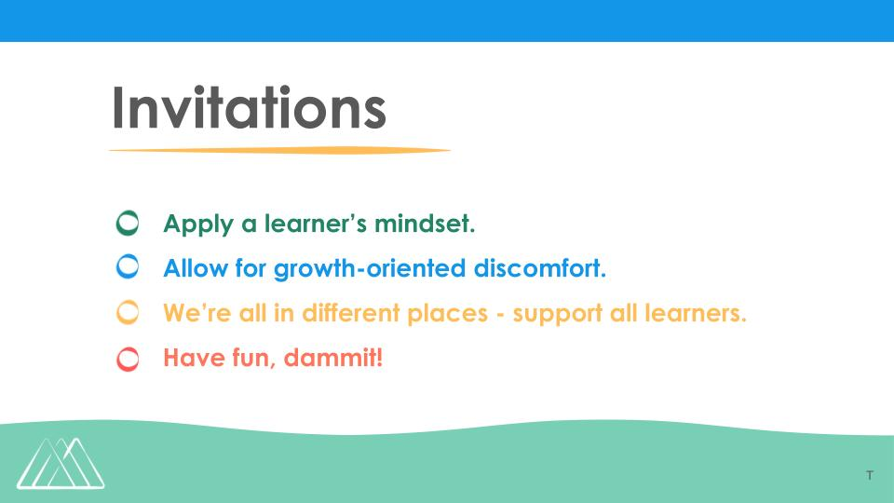

You Want Me? Download Me :)

LASTLY, BUT NOT LEASTLY: HELP US!
Want to help us make this workshop better? Take our workshop survey (a few min) and add your headshot (optional) to The Faces of The Oath on our website homepage!

Take The Survey

Thank you so very much for your commitment,
-- Gabaccia, José, Pattie, & Teresa - The Oath Team

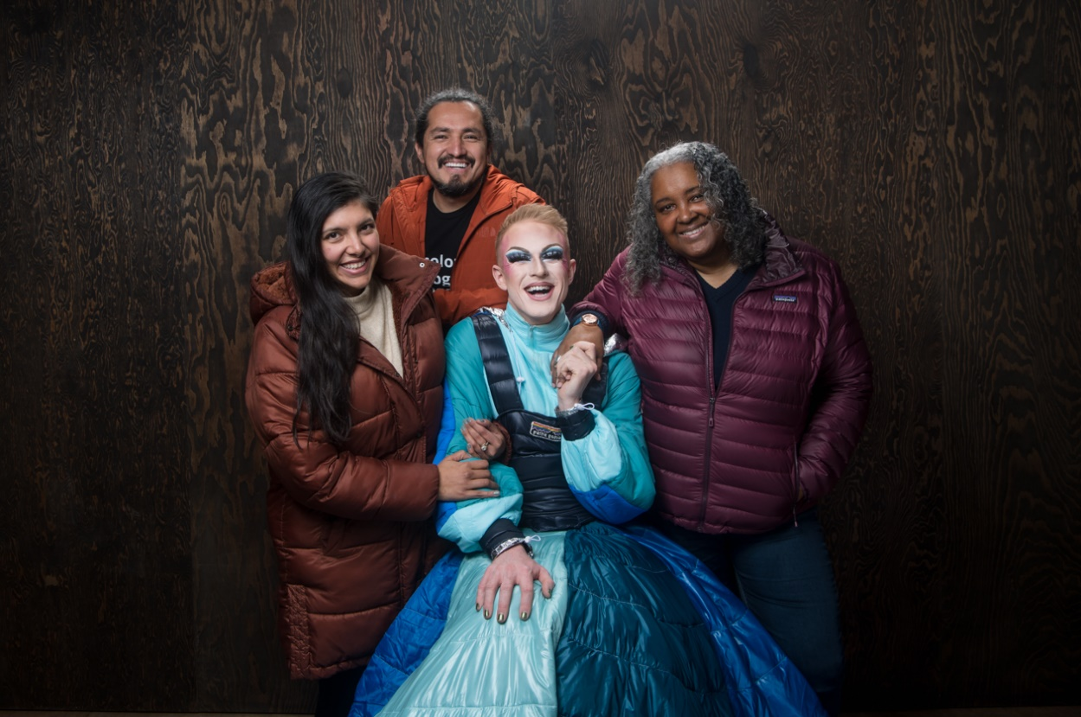







Copyright © 2022 Outdoorist Oath, All rights reserved.
Want to change how you receive these emails?
You can update your preferences or unsubscribe from this list.


